## ASSIGNMENT-04

## Create a private bucket in AWS.Upload a file and check by presigned URL that you can access the file or not.

## 1.Sign in to AWS

## .Login to AWS Management Console.

## .Navigate to the Amazon S3 Service by selecting it from AWS Services list.

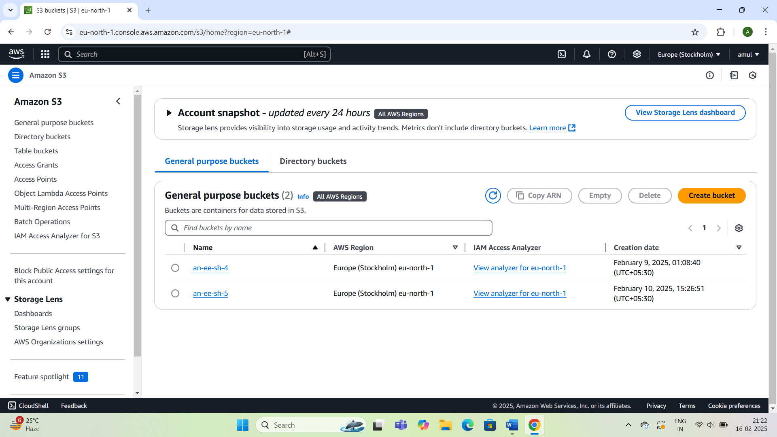

## 2.Create a Private Bucket

## 1.In the S3 console,click on buckets in the left navigation pane.

## 2.Select the Create bucket button.

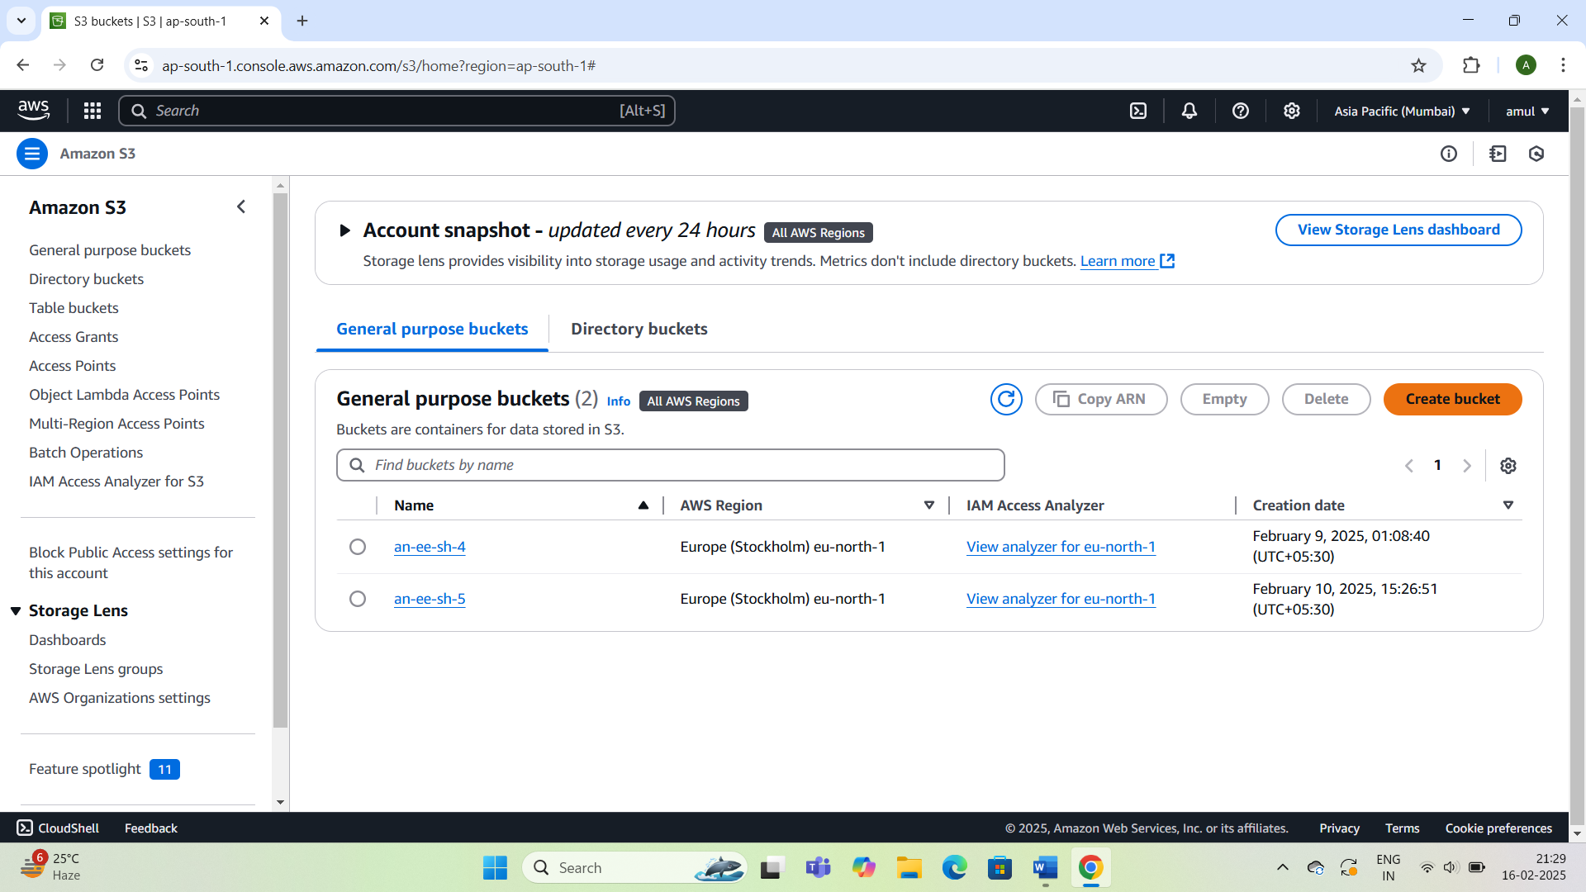

## 3.Provide a unique name for your bucket(eg;myprivatebucket).

## .Ensure the name:

## .Is unique globally.

## .Has 3-63 characters,including lowercase letters,numbers,dots or hyphens.

## .Remark:Avoid using dots unless hosting a static website.

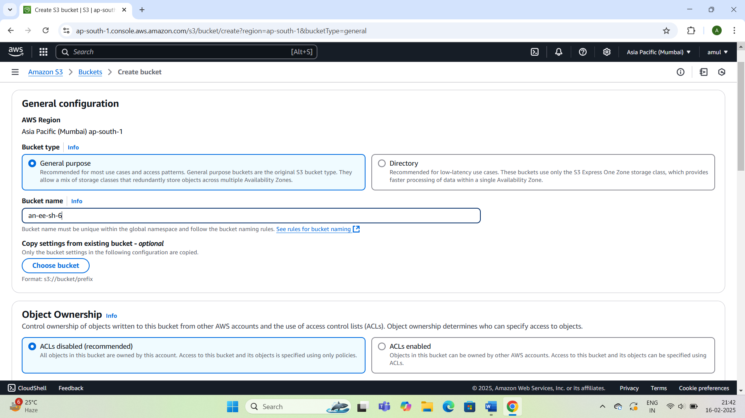

## 4.Select the desired AWS Region for your bucket.

## 5.Under Object Ownership,choose “Bucket Owner enforced”to disable ACLs and enforce bucket-level permissions.

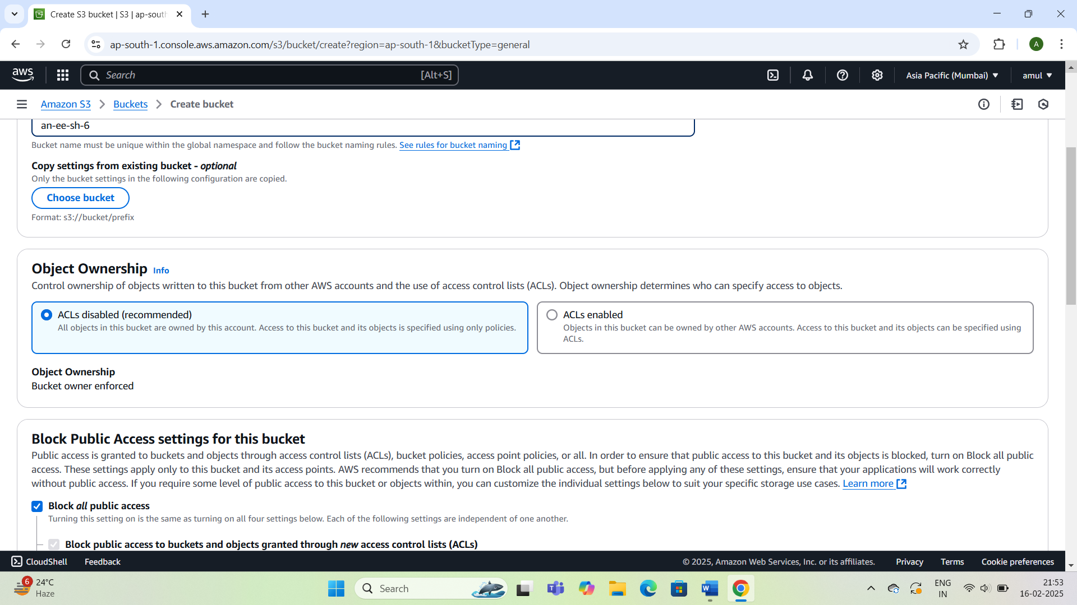

## 6.Enable the Block Public Access settings by checking appropriate checkboxes.

## 

## .Remark:This ensures the bucket remains private and inaccessible to the public.

## 7.Click create bucket.

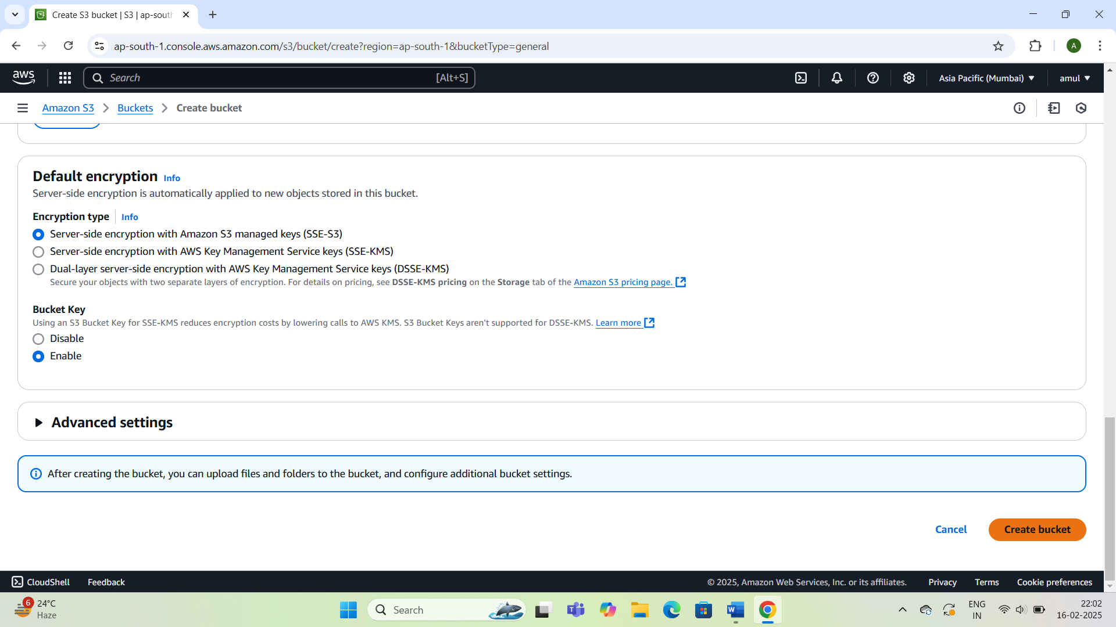

## 3.Upload Files to the bucket:

## 1.After the bucket is created,it will appear in the bucket list.Click on newly created bucket.

## 2.In the bucket view,click Upload.

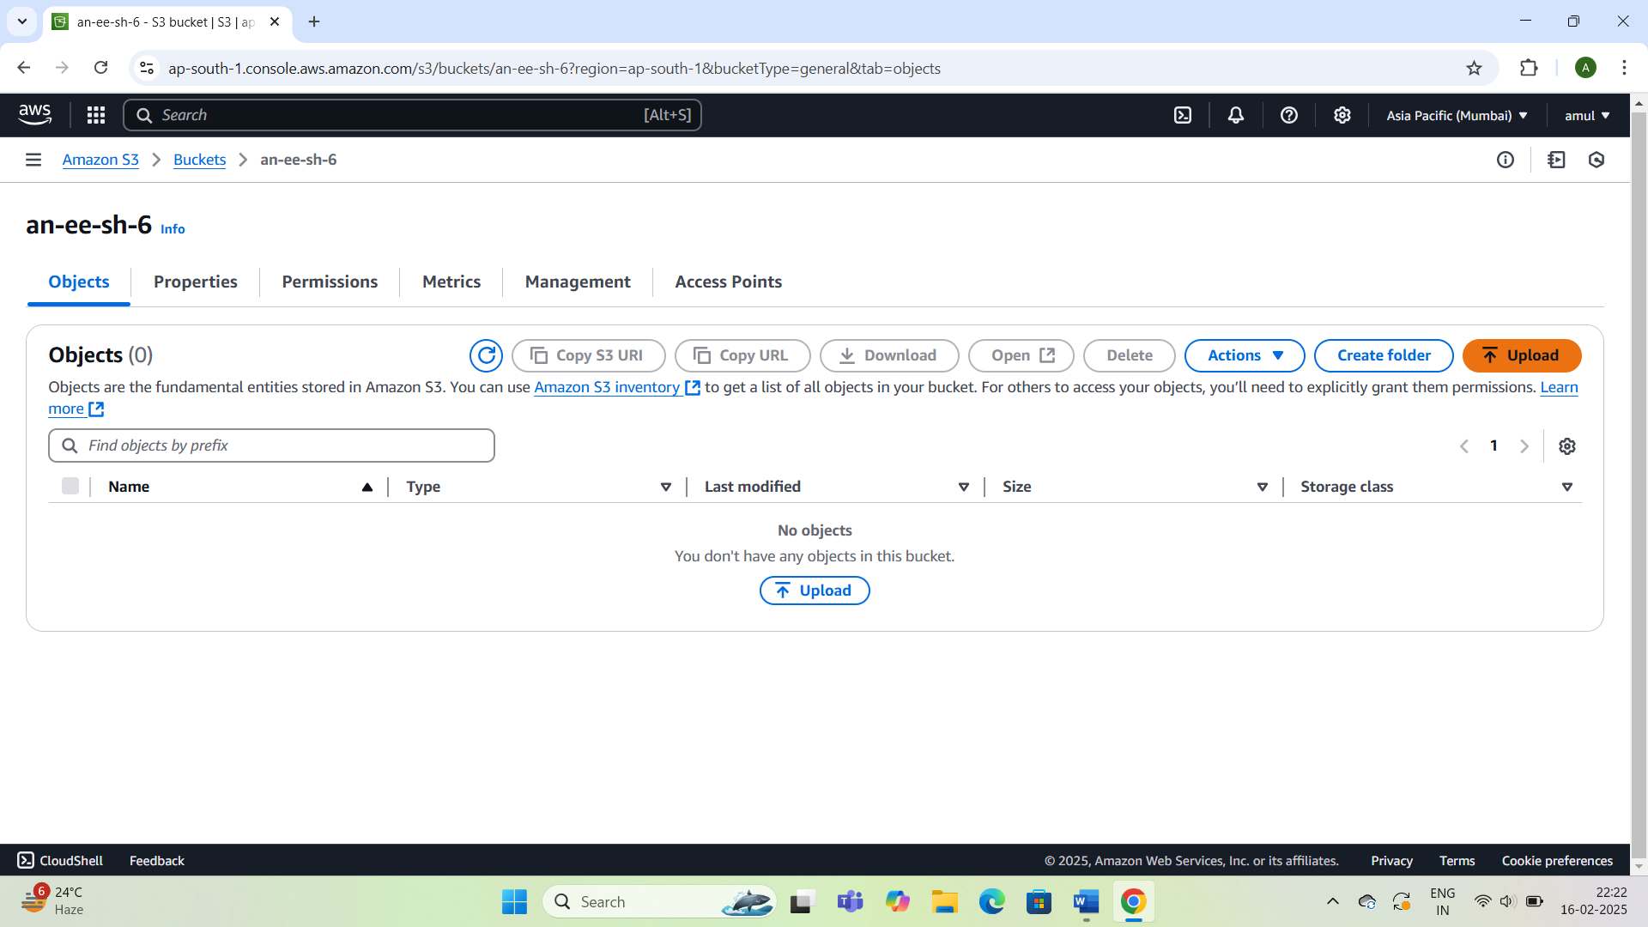

## 3.On the upload page:

## .Click Add Files to select the file you want to upload.

## .Click Upload to complete the process.

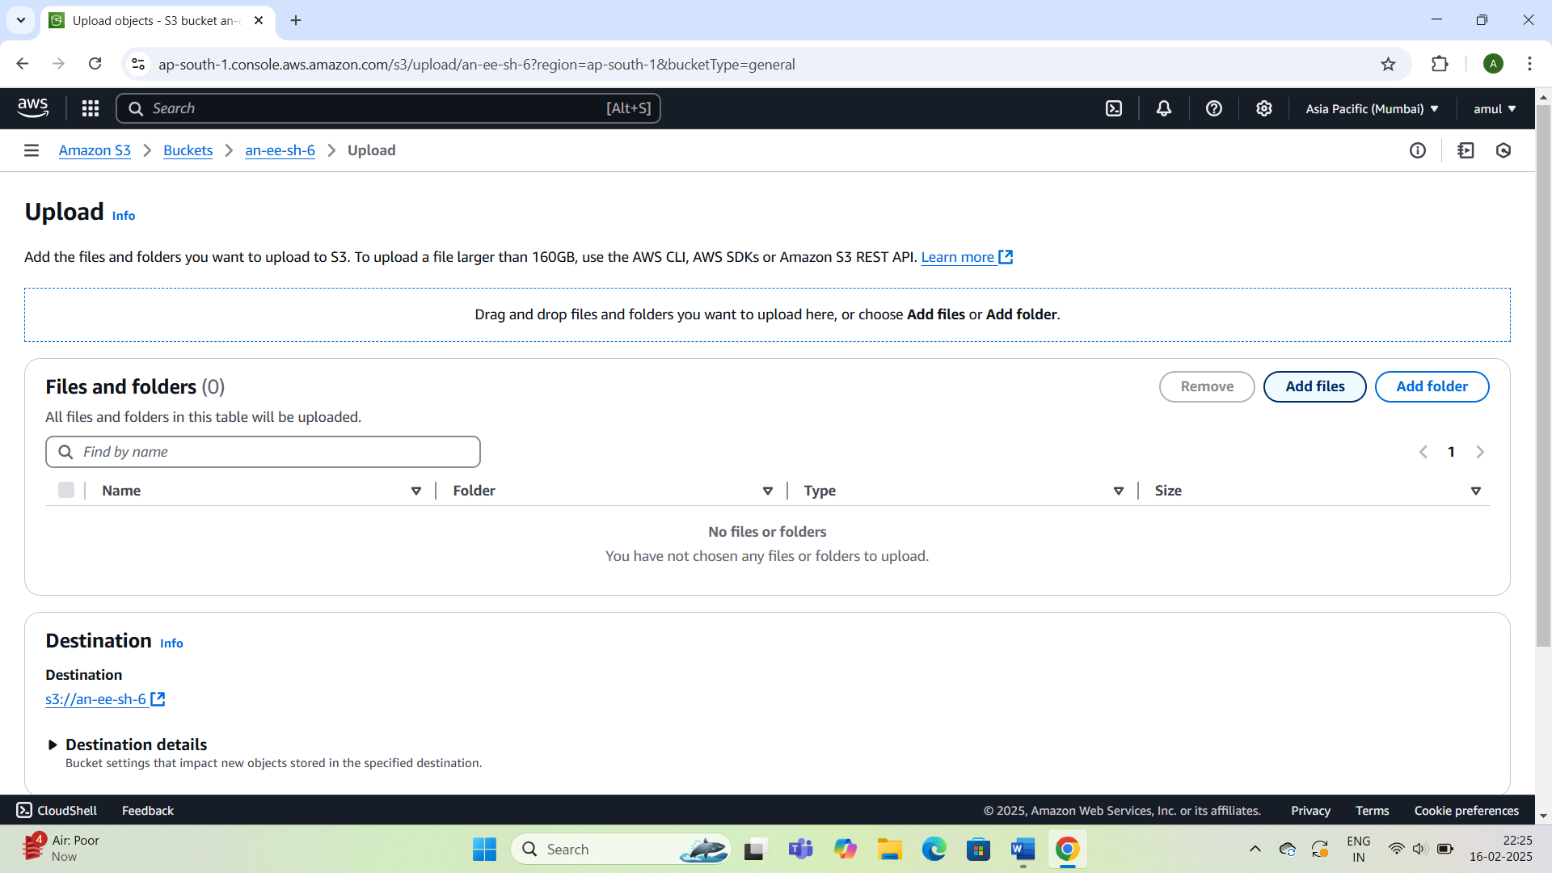

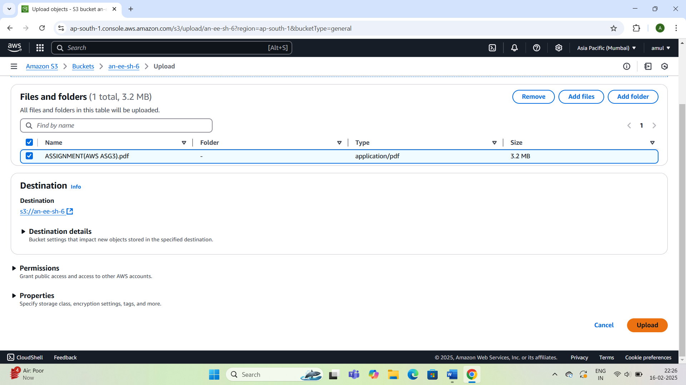

## 4.Verify Upload:

## .The uploaded files will be visible in the bucket.

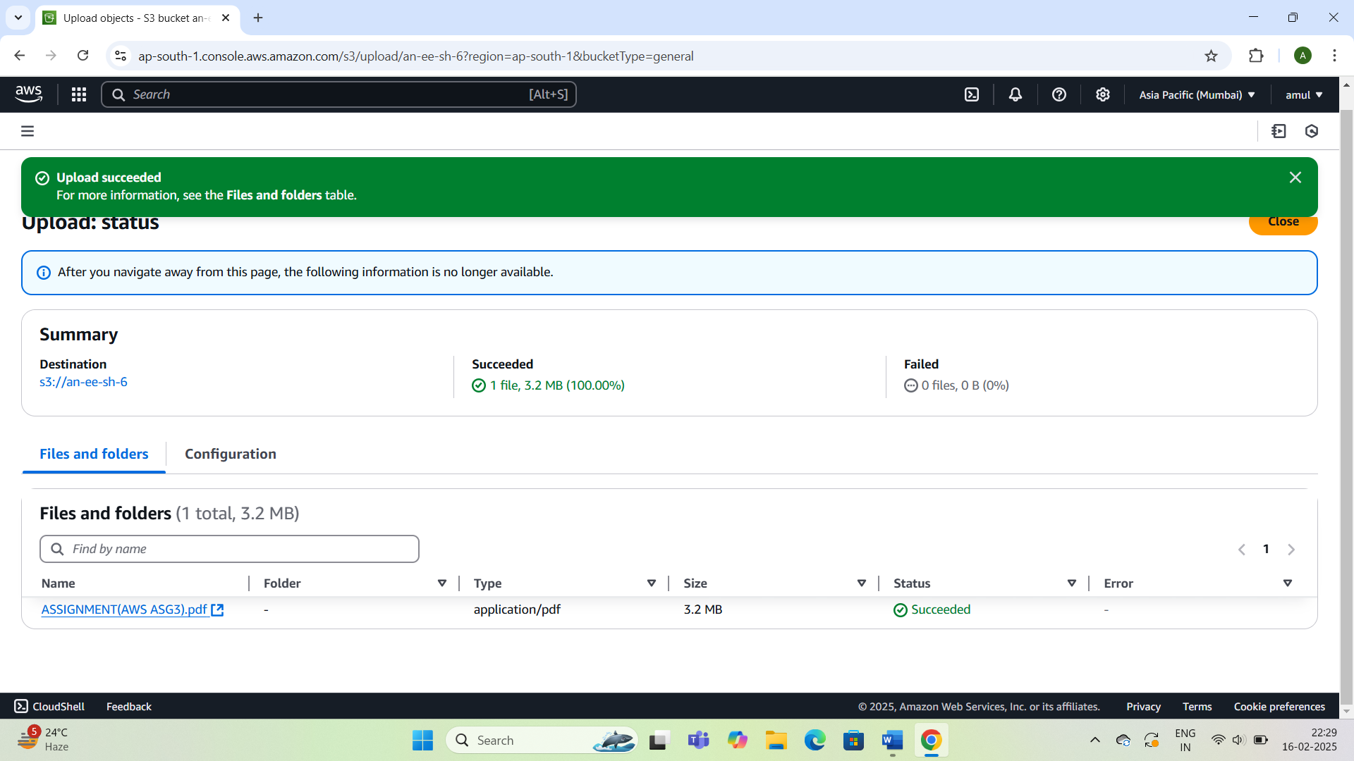

## 4.Test File Privacy:

## 1.Select the uploaded file and locate its Object URL in the file’s properties.

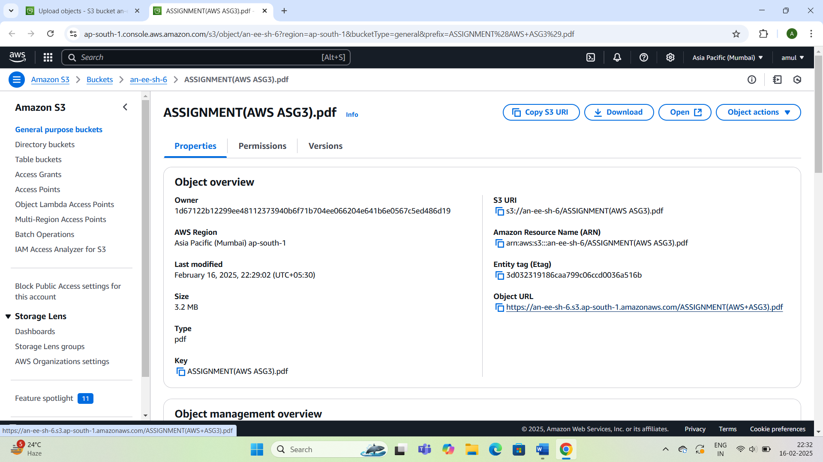

## 2.Open the Object URL in a web browser.You should see an “Access denied” message indicating the file is private.

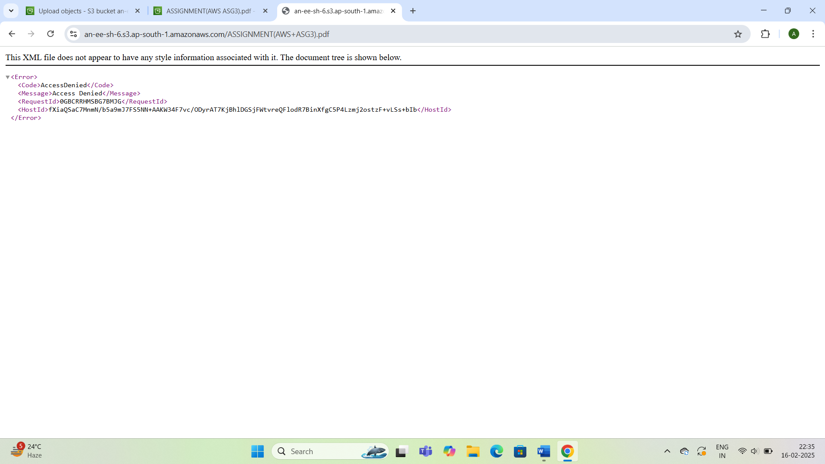

## 5.Create a Predesigned URL

## 1.Go to your bucket and locate the uploaded file.

## 2.Select the file and click on Actions>Shared with presigned URL.

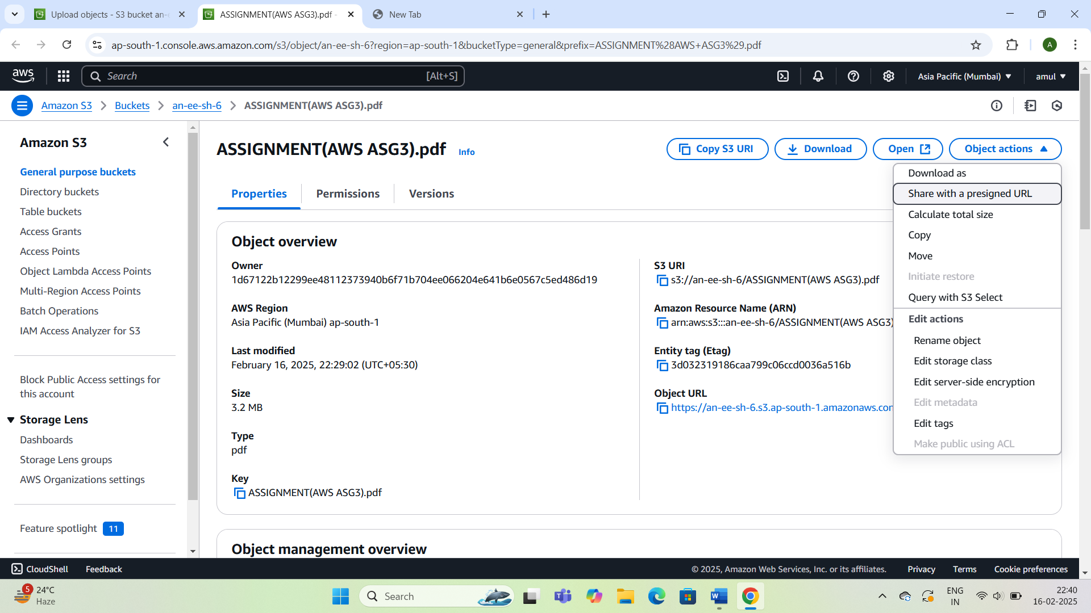

## 3.Specify the expiration time for presigned URL.

## .Remark:Choose an appropriate time based on required access duration(e.g.5 minutes).

## 4.Click Create presigned URL.

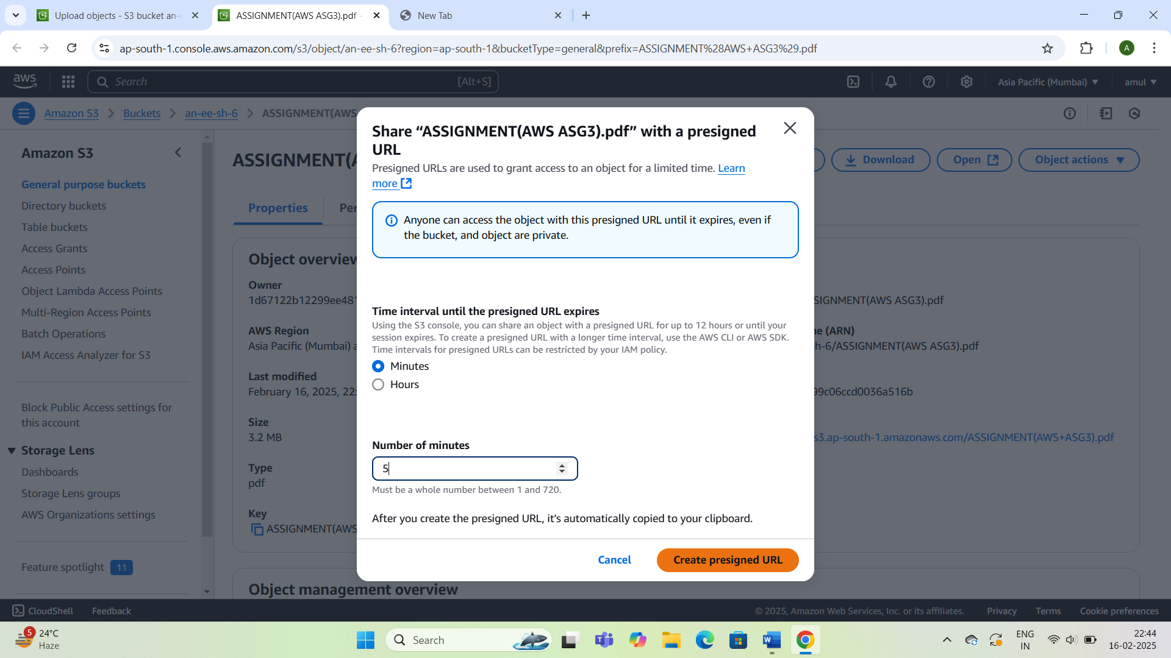

## 6.Access the File using the Presigned URL

## 1.Copy the generated presigned URL.

## 2.Paste the URL into new browser tab and press Enter.

## 3.Expected Output:The file will be accessible publicly until URL expires.

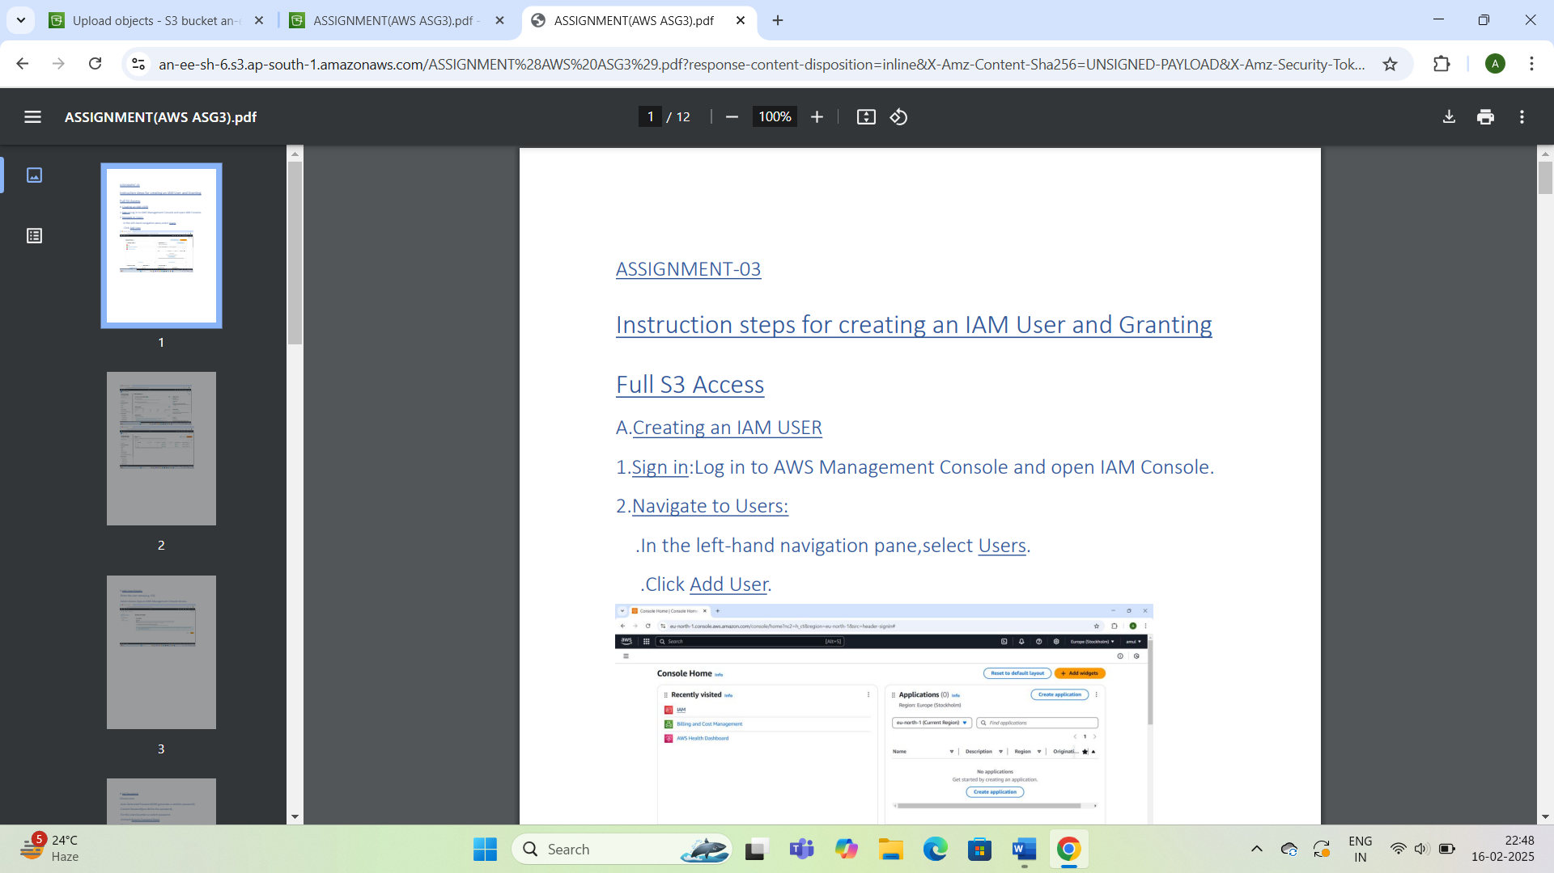

## .Reduces unauthorized access risks.

## .Regularly review bucket permissions to maintain security.

## .Ideal for temporarily sharing private files securely.